Mr Collins 4th Class assessment
Part 1: Comprehension
Read the text.
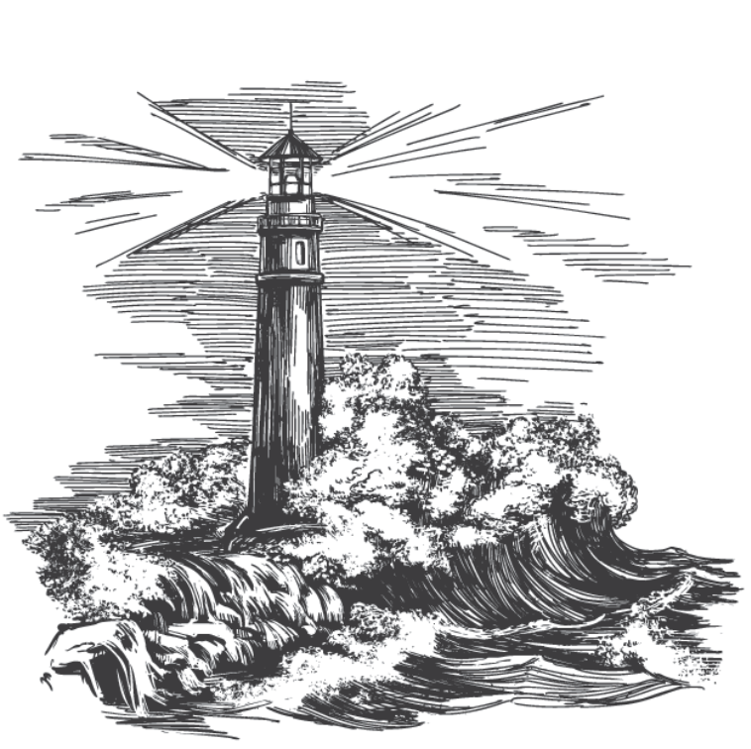
Extreme Irish Weather
You’ve probably heard news reports of natural disasters. In some parts of the world, floods, earthquakes, hurricanes and mudslides cause chaos. Disasters like this can devastate people’s lives. In the aftermath of disasters, governments and charities around the world help people to rebuild their lives.
In Ireland, extreme weather is certainly much rarer. But earthquakes, hurricanes and mudslides do sometimes happen here too!
Storm Ophelia
You may have heard of Storm Ophelia, which struck Ireland in October 2017. But did you know that Storm Ophelia was actually a hurricane? It began in the Atlantic Ocean, and it was the strongest hurricane to hit the East Atlantic coast in over 150 years. It pounded ashore in Co. Cork with wind speeds of up to 156 kilometres per hour. That’s as fast as a train! Storm Ophelia caused floods and damaged buildings across Ireland, and at least three people died as a result of fallen trees.
Mudslide in Donegal
You’ve read about the terrible mudslide in Sierra Leone in August 2017. But strangely enough, a mudslide also happened in Donegal that same month. As in Sierra Leone, the mudslide was caused by flooding. A cascade of mud and rocks tumbled down a hillside in Urris. It destroyed at least one house – although, luckily the owner escaped. Mudslides are scarce in Ireland, but they can be devastating when they do occur.
Irish Earthquakes
It might surprise you to learn that earthquakes are quite common in Ireland! Most of these earthquakes are so tiny, you probably wouldn’t even feel them. But we sometimes experience a more powerful quake. For example, on 7 April 2019, a larger earthquake occurred near Killybegs in Donegal. This quake was felt by hundreds of people, who sensed a rumble like thunder and felt their houses shake. No damage was done, fortunately.
In conclusion, most of our weather in Ireland is quite mild. However, sometimes more extreme weather does occur – including earthquakes!

A. Tick the correct answers.
1. Name a hurricane that struck Ireland.   Hurricane Herbert   Storm Ophelia   Sierra Leone  3. Which town was struck by the mudslide?   Donegal   Urris   Killybegs  5. How many people felt the Donegal earthquake?   Fewer than 10   More than 100   More than 10,000 | 2. When did the mudslide happen?   August 2017   April 2019   October 2017  4. What are most Irish earthquakes like?   Large and powerful   Nothing – we never have earthquakes   Tiny and not very dangerous  6. Which statement is true?   The mudslide caused no damage.   The earthquake caused lots of damage.   The hurricane caused lots of damage.

B. Answer the questions.
- Which of the extreme weather events in this report did the most damage?

- What kind of damage can extreme weather events cause?

- What does the author compare the speed of Storm Ophelia to? Why might the author make this comparison?

- Do you think Ireland would be a good country for someone to visit if they wanted to experience extreme weather? Explain your views.

- Which fact in this report did you find most surprising? Why?

Part 2: Vocabulary
Underline the word closest to the meaning given.
1. tribe government owners 2. occasion aftermath rafters
meaning: group in charge of a country meaning: happens after something
3. scarce plentiful impossible 4. sensed wanted meant
meaning: not common meaning: were aware of something
5. organisation plunder chaos 6. sprinted escaped preyed
meaning: disorder meaning: got away from
7. pounded pumped erupted 8. unpick reduce devastate
meaning: hit hard meaning: destroy
9. puddle cascade drop 10. certainly mostly partly
meaning: pour down meaning: definitely
Part 3: Grammar
Rewrite the following sentences, filling each gap with an appropriate conjunction. Eg. While, when but, and, then
- Dad read us a story we were waiting.

- I finished before Sinéad but Michael in the race.

- Mam was pleased with us we did the washing-up.

Part 4: Writing
Write a short report about your town or village.
Remember to:
- Give your report a title that says what it’s about.
- Start with an introduction and finish with a conclusion.
- Include lots of facts about the place.
- Organise your report into paragraphs with subheadings – each paragraph can be about a different topic, such as local buildings, places of interest, town history, etc.
- Check your spelling, grammar and punctuation.

