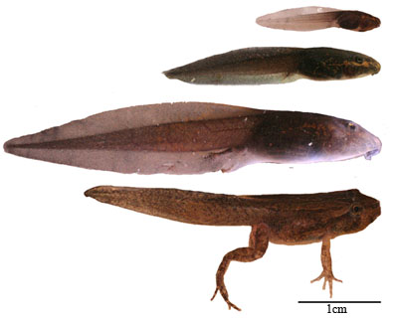
Tráth na gCeist a 1
1: What sort of animal is Basil Brush? Fox
2: What is the name of Donald Duck’s girlfriend? Daisy
3: A Mega is ten to the power of 6. What is a Giga ? Ten to the power of nine.
That is one followed by nine zeros.
4: Which resident of Jellystone Park is “smarter than the average bear”? Yogi Bear
5: What is the name of Shrek’s wife? Fiona
6: What is the name of the hero in The Lion King? Simba.
7: What is the largest planet in the solar system? Jupiter
8: What colour are dandelions? Yellow
9: What term in mathematics refers to the number obtained when two or more numbers are multiplied? Product.
10: How many sides does a heXagon have? SiX
11: What is the innermost colour of a rainbow? Violet.
(Ring Out Your Great Bells In Victory
Red Orange Yellow Green Blue Indigo Violet)

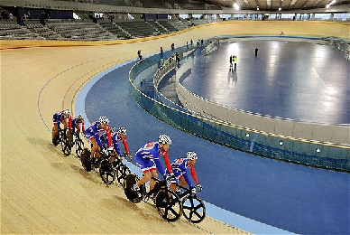
Dearg Oraiste Buí Glas Gorm Indigo Violet
12: Feline means relating to what sort of animal? Cat
13: Comice, Conference and Williams are varieties of which fruit? Pear.
14: What are the young of frogs and toads called? Tadpoles.
15: In computing, what is Mb short for? Megabyte.
16: Complete the pair. Dr. Jekyll and…Mr. Hyde
17: In which sport do Europe and America compete for the Ryder Cup? Golf
18: What is the more familiar name for the disease rubella?
German Measles.
19: Vienna is the capital of which country? Austria.
20: In photography, what sort of lens enables a speedy transition from long shots to close-ups? Zoom.
21: Which animals live in lodges and are notable for gnawing trees? Beavers.
22: Which star can be used to work out where due North is?
The Pole Star. (Polaris.)
23: What name is given to the collection of 22 bones found in the head? The skull.
24: Which tree has a variety called “Weeping”? Willow
25: Which jet-black bird has lived in the Tower of London for centuries? Ravens.
26:Which stone, a form of calcium carbonate, are the White Cliffs of Dover made of? Chalk.
27: Cocker, Springer and King Charles are varieties of which breed of dog? Spaniel.
28: Which leaves can be used to soothe the pain from stinging nettles? Dock leaves.
29: What turns red in the presence of acid and blue in the presence of alkali? Litmus paper.
30: The name for which group of prehistoric animals comes from the Greek for “terrible lizard”? Dinosaur.
31: What is the term for when the moon passes between the earth and the sun, blocking out light from the latter? Solar eclipse.
32: Crawl, backstroke and butterfly are different methods in which sport? Swimming.
33: Which game is played in autumn using the fruit of the horse chestnut tree? Conkers
34: What is the object hit by the players in ice hockey called? Puck
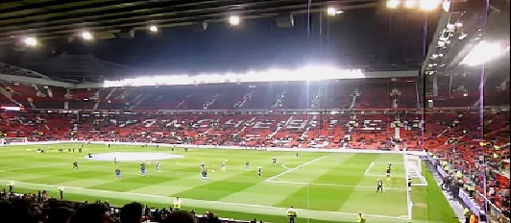

35: With five victories to date, what team had won the Fifa World Cup the most times? Brazil.
36: Which sport takes place in a velodrome? Bicycle racing.
37: Which famous horse race is run at Aintree on a Saturday in spring? Grand National.
38: From what country does Lego come? Denmark
Lego also makes the largest number of tyres in the world.
Popular trick question.
39: What is the name of the Australian throwing stick that can return to its thrower? Boomerang.
40 What term in tenpin bowling describes having knocked all the pins down after your second bowl? A Spare.
What is a “strike” in bowling?
41 What is the name of Manchester United’s home ground?
Old Trafford.
42 How many holes are there on a standard golf course? 18
43 Which chess piece can only move diagonally? Bishop
44: Which breakfast cereal is advertised with the slogan “Snap, crackle and pop”? Rice Crispies.
45: In netball, for what does WA stand? Wing Attack.
46: How many pieces does a player have in Ludo? Four
47: What term is used in tennis for 40-40? Deuce.
48: What sort of animal is the video game character Sonic? Hedgehog.
49: Tick-tack-toe is an alternative name for which game? X’s and O’s
50: Ping-pong is an alternative name for which sport? Table tennis.
51: What term is used in cricket for the two men on the field who decide on whether batsmen are out, and signal for extras and boundaries? Umpires.
52: What colour belt are martial arts experts entitled to wear? Black.
53: Which is larger in size: America or Canada ? Canada
54: How many zeros follow one, when you write a million? 6
55: In which sport might you do a slam dunk? Basketball.
56: At more than 6.5 million square miles, what is the largest country in the world? Russia.
57: Which country has the largest population, at more than 1.3 billion, in the world? China.
58: What is the capital city of Spain? Madrid.
[Highest capital in Europe.]
59: How long does it take the earth to complete one rotation on its axis? One day
60: Which sea separates Europe from Africa? Mediterranean.

